Samuel Chukwuemeka B.Eng., A.A.T, M.Ed., M.S
www.samuelchukwuemeka.com
www.chukwuemeka-samuel.appspot.com
“The Joy of a Teacher is the Success of his Students.” – Samuel Chukwuemeka

Correlation and Regression
Videos: Correlation and Regression
Technology Used: Correlation and Regression Calculator
Google Spreadsheets
TI-84 (and higher) Family
Pearson Statcrunch
Microsoft Excel
Table Used: Critical Values of the Correlation Coefficient

Objectives
Students will:
- Define the terms used in Correlation and Regression.
- Explain the terms used in Correlation and Regression.
Let’s Discuss. What are your thoughts?
Let’s discuss relationships (or associations or correlation). Hmmm…..I do not mean the “relationship” you are probably thinking aboutJ. We are doing Statistics, not Family Studies lol.

Do you see any relationship between these variables?
The number of cheeseburgers and weight
Before I immigrated to the United States, I was a skinny guy. I then arrived here and ate McDonald’s cheeseburgers. Now, I have fat cheeks and a big stomach.




The weight of a car and the mileage
Article to read and discuss:
https://www.wired.com/2012/08/fuel-economy-vs-mass/
https://www.autoblog.com/2009/10/29/greenlings-how-does-weight-affect-a-vehicles-efficiency/
Obesity and Diabetes
Articles to read and discuss:
https://www.ncbi.nlm.nih.gov/pubmed/21128002
http://www.obesity.org/content/weight-diabetes

Socioeconomic status (SES) and Health
Articles to read and discuss:
https://www.ncbi.nlm.nih.gov/books/NBK25526/
http://www.apa.org/pi/ses/resources/publications/work-stress-health.aspx

Old Age and Osteoarthritis
Article to read and discuss:
https://www.ncbi.nlm.nih.gov/pmc/articles/PMC2818253/

Runny nose and headache (and so much more…)
Is headache associated with runny nose? What do you think?
Article to read and discuss:
http://healthymedinfo.blogspot.com/2012/09/fever-and-headache-causes-and-treatment.html

Let’s discuss cause and effect (or causation).
Let’s review our previous examples.
Does cheeseburgers cause a gain in weight? Is a weight gain caused by the number of cheeseburgers one eats?
Good mileage is associated with lightweight cars. However, does the weight of a car cause better fuel economy?
In a nationally representative sample of US adults, the prevalence of diabetes increases with increasing weight classes. Nguyen, N. T., Nguyen, X. M., Lane, J., & Wang, P. (2011, March). Diabetes is strongly related to obesity. But, does obesity cause diabetes?
In the United States, people with less education have worse health outcomes. Anderson, N. B. (1970, January 01). But, does it mean that less education causes bad health?
Osteoarthritis is a multi-factorial condition for which aging is the major risk factor. Anderson, A. S., & Loeser, R. F. (2010, February). Arthritis is associated with old age. However, does old age cause arthritis?
Fever and headache can go hand in hand during an illness. Many infectious diseases are in fact heralded by the tandem of headache and fever. D. (n.d.). Headache is associated with fever. However, does fever cause headache?

Some of your responses are probably “yes”. Some are probably “no”.
So, what do you think are the differences between Correlation and Causation?
Let’s look at these two scenarios. I just want you to understand these concepts.
Headache is associated with Fever. However, fever does not cause headache. Neither does headache cause fever. This is a Correlation (because of the association). This is not a Causation (as it has no causal relationship).

Smoking tobacco is associated with Lung Cancer. Actually, smoking causes lung cancer. This is a Correlation (because of the relationship). This is also Causation.

from http://web.cn.edu/kwheeler/logic_causation.html
“For instance, consider New York City in the 1980s. The city at that time was a dangerous place. Crime was at an all-time high then. Murders, prostitution, and drug-dealing had reached epic levels. New York had tried stiffer penalties, longer jail terms, mandatory counseling, methadone treatments, and a variety of other approaches without denting the ugly problem. Mayor Guiliani hired researchers to come in. What was one of the early findings? Analysts spotted a correlation between graffiti in an inner-city neighborhood and the relative crime-rate in that area. The more graffiti, the higher the crime rate. Treating this as a cause/effect relationship, New York's mayor Guiliani decided to alter the funding for the police department, cutting back money for some types of law-enforcement, pouring money into an city-wide anti-graffiti campaign, and arguing that a cleaner city would diminish the visual "mindset" of crime in the area. He enacted a zero-tolerance policy by prosecuting taggers who painted on public property, and he cleaned up Times Square and the trashiest parts of the city. As overall crime rates dropped in the 1990s, the mayor touted his program as a success.
Impressed and surprised, other cities tried to duplicate New York's approach. They enacted similar financial policies and created similar laws. They hauled in hoodlums and cleaned up graffiti . . . and they all failed miserably. Crime in these cities either remained the same or in one or two cases, worsened slightly, even though the changes they made were nearly identical to that of New York.
What happened? Why couldn't they duplicate New York's success? The problem may be one of false causation. That correlation between the amount of graffiti and the overall crime rate doesn't necessarily mean that graffiti causes crime to happen--no more than the correlation between black eyes and broken noses in people who lose fist fights means that black eyes "cause" broken noses. The crime-rate in an area also correlates to the rate of unemployment, for example, and New York's unemployment was dropping steadily through the 1990s. Perhaps rising employment caused crime to drop at just about the same time the mayor started his anti-graffiti campaign. The rate of drug abuse in a given area also correlates to the number of crimes in that area. The city had started constructing larger drug treatment clinics in the late 1980s after the decade's peak of cocaine addiction. Although the construction funding had been spent in the late 1980s without visible effect, many of these clinics actually started operation only two or three years before the fall in crime in the early 1990s. Perhaps after two or three years of treatment, a significant fraction of cured addicts no longer needed to engage in crime sprees to support an expensive and illicit habit. It's not at all clear if there was just one cause--maybe the combination of rising employment, drug clinics, and the mayor's anti-graffiti campaign together had a synergistic effect that was missing in other cities where the anti-graffiti program didn't work. One recent book on applied economic theory, entitled Freakonomics, has gone so far as to suggest plausibly the source of the crime-drop nationwide in the late 1990s and the early 2000s has been an unintentional result or by-product of abortion policies thirty years earlier!”

So far, we have been discussing in two-variable relationships. Let us define it in that sense.
Correlation is an association between two variables. The two variables are the response variable, $y$ and the predictor or explanatory variable,$x$. The association may or may not be causal. Causation is an association between two variables in which a change in one variable causes a change in the other variable, otherwise known as cause and effect.

Bring it to Statistics
$$x=predictor or explanatory variable$$
$$y=response variable$$

Bring it to Algebra and Calculus
$$x=independent variable$$
$$y=dependent variable$$
Bring it to Economics / Marketing / Nutrition
$$x=input$$
$$y=output$$

Bring it to Philosophy
$$x=cause$$
$$y=effect$$

Bring it to English
$$x=action$$
$$y=consequences$$

Correlation could be linear or nonlinear.
A Linear Correlation is the correlation that shows a linear relationship between the variables. Linear correlation could be positive linear correlation or negative linear correlation.
A Positive Linear Correlation shows a direct relationship in which an increase in the predictor variable leads to an increase in the response variable, and a decrease in the predictor variable leads to a decrease in the response variable.
A Negative Linear Correlation shows an inverse relationship in which an increase in the predictor variable leads to a decrease in the response variable, and a decrease in the predictor variable leads to an increase in the response variable.

Measures of Correlation
The measures of correlation include:
- Scatter Diagrams
- Pearson Correlation Coefficient or Product Moment Correlation Coefficient
- Spearman’s Rank Correlation Coefficient
- Coefficient of Determination

Scatter Diagrams or Scatter Plots
A scatter diagram is a graph that shows the relationship between two variables, the response variable and the predictor variable. The response variable is plotted on the vertical axis $(y-axis)$, and the predictor variable is plotted on the horizontal axis, $x-axis)$. When studying scatter diagrams, we examine the trend (measure of center), the strength (measure of spread), and the shape.
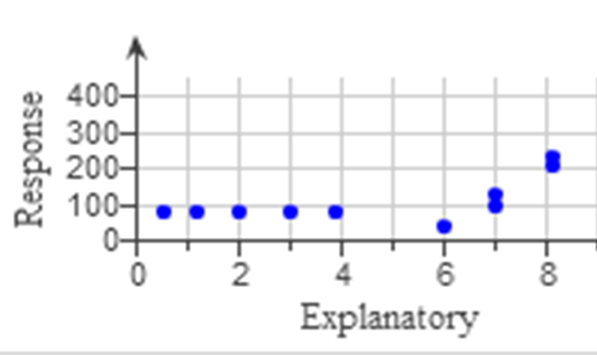 | 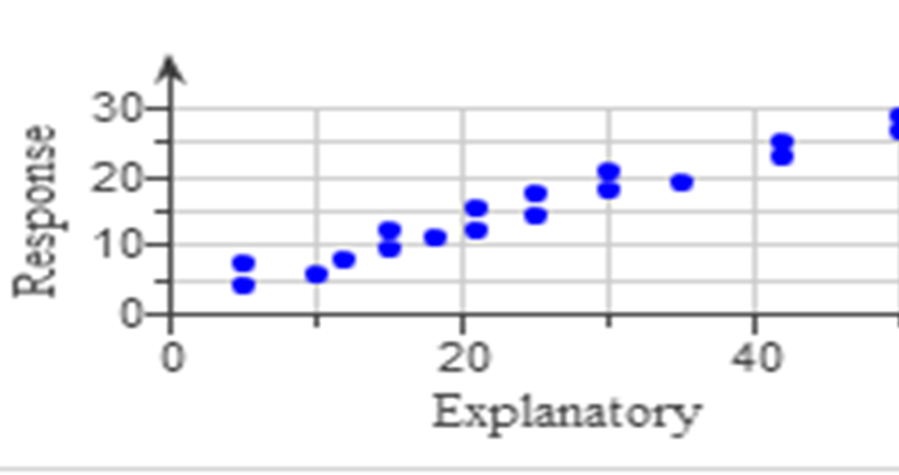 | 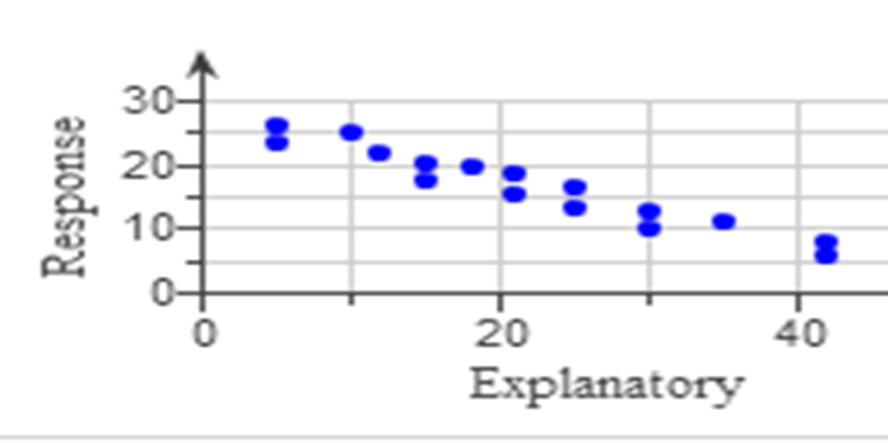
Non-linear  Relationship  The data points do not  have a linear relationship  because they do not lie  mainly in a straight line. | Positive Linear  Relationship  The data points have a linear  relationship because they  lie mainly in a straight  line. | Negative Linear  Relationship  The data points have a  linear relationship  because they lie mainly  in a straight line.

Pearson Correlation Coefficient

References

Anderson, A. S., & Loeser, R. F. (2010, February). Why is Osteoarthritis an Age-Related Disease? Retrieved September 27, 2017, from https://www.ncbi.nlm.nih.gov/pmc/articles/PMC2818253/

Anderson, N. B. (1970, January 01). Race/Ethnicity, Socioeconomic Status, and Health. Retrieved September 27, 2017, from https://www.ncbi.nlm.nih.gov/books/NBK25526/

Chukwuemeka, S. D. (2016, January 15). Samuel Chukwuemeka Tutorials – Math, Science, and Technology. Retrieved from http://www.samuelchukwuemeka.com/

Gould, R. & Ryan, C. (2016). Introductory Statistics - Exploring the world through data (2nd ed.). Pearson.

Nguyen, N. T., Nguyen, X. M., Lane, J., & Wang, P. (2011, March). Relationship between obesity and diabetes in a US adult population: findings from the National Health and Nutrition Examination Survey, 1999-2006. Retrieved September 27, 2017, from https://www.ncbi.nlm.nih.gov/pubmed/21128002

Smoking facts and evidence. (2017, June 26). Retrieved September 27, 2017, from http://www.cancerresearchuk.org/about-cancer/causes-of-cancer/smoking-and-cancer/smoking-facts-and-evidence#smoking_facts0

Sullivan, Michael. (2013). Statistics - Informed Decisions using data (4th ed.). Pearson.

Triola, M. F. (2015). Elementary statistics using the TI-83/84 plus calculator (4th ed.). Pearson.

D. (n.d.). Health Information for Your Health Needs. Retrieved September 27, 2017, from http://healthymedinfo.blogspot.com/2012/09/fever-and-headache-causes-and-treatment.html

(n.d.). Retrieved September 27, 2017, from http://web.cn.edu/kwheeler/logic_causation.html

